Deep Dive on Accumulated Local Effect Plots (ALEs) with Python

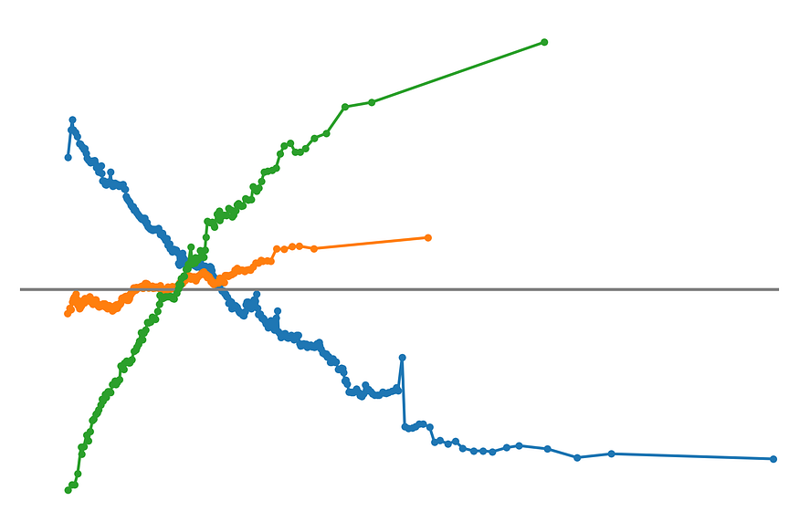
Highly correlated features can wreak havoc on your model interpretations. They violate the assumptions of many XAI methods and make it difficult to understand the nature of a feature’s relationship with the target. At the same time, it is not always possible to remove them without affecting performance. We need a method that can provide clear interpretations, even with multicollinearity. Thankfully we can rely on ALEs [1].
ALEs are a global interpretation method. Like PDPs they show the trends captured by the model. That is if a feature has a linear, non-linear or no relationship with the target variable. However, we will see that the method of identifying these trends is quite different. We will:
- Give you the intuition for how ALEs are created.
- Formally define the algorithm used to create ALEs.
- Apply ALEs using the Alibi Explain package.
We will see that, unlike other XAI methods like SHAP, LIME, ICE Plots and Friedman’s H-stat, ALEs give interpretations that are robust to multicollinearity.
You may also enjoy this video on the topic. And, if you want to learn more, check out my course — XAI with Python. You can get free access if you sign up to my newsletter.

Understanding ALEs
We will use the abalone dataset to understand how ALEs work. Abalone is a shellfish delicacy. We want to predict the number of rings in their shell using features like shell weight and shucked weight (weight of the meat). Figure 1 shows the correlation heatmap for all the numerical features in this dataset. We are dealing with some highly correlated features!
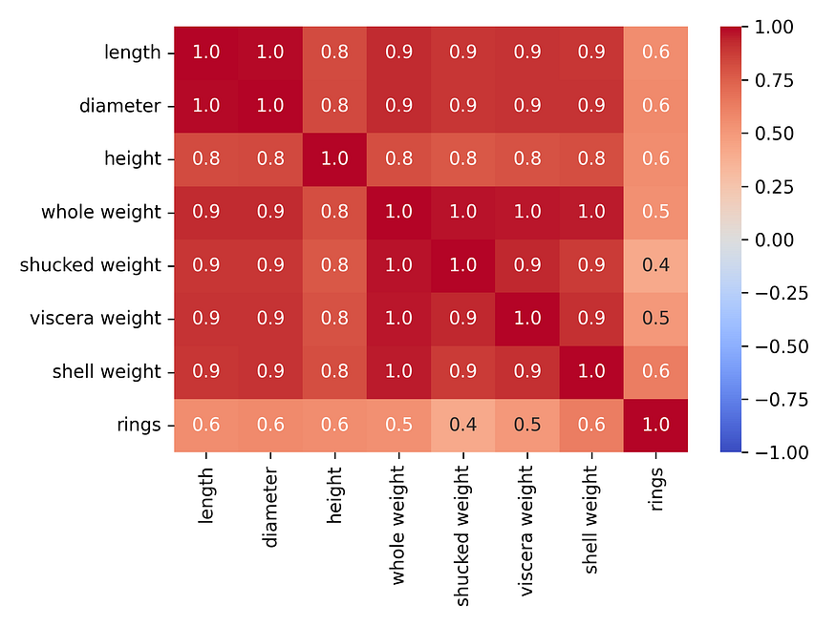
Figure 1: correlation heatmap for the numerical features in the abalone dataset
Figure 2 gives a scatter plot for two of these features — shucked weight and shell weight. We can see why these had a correlation value of 0.9. Now consider the red instance. It has a shell weight of 0.2 and instances like this will have a shucked weight roughly between 0.2 and 0.5. Many XAI methods would not consider this.
- PDPs would sample the entire range of shucked weight.
- Permutation feature importance would randomly shuffle shucked weight values.
In other words, using these methods we would get unlikely or even impossible feature pairs. The key to solving this problem is to consider the range.
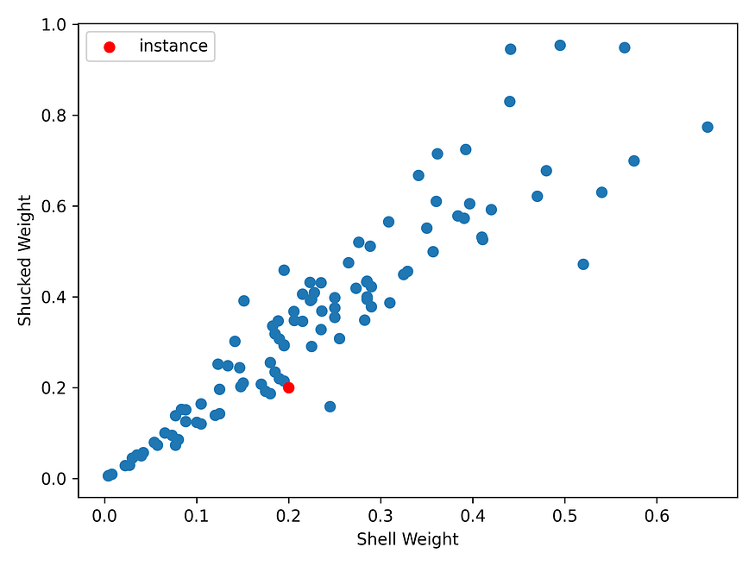
Figure 2: scatterplot of shucked weight vs shell weight. A sample of 100 instances from the abalone dataset has been used.
Correlations can only be calculated using the entire range of both features. If we only look at the instances within a small interval then the correlation is meaningless. You can see this in Figure 3. We have created an interval around the red instance by only considering instances with a shell weight between 1.5 and 2.5. The plot on the right shows that, in this interval, the correlation is not as obvious. A smaller interval would make it even less obvious. ALEs take advantage of this.
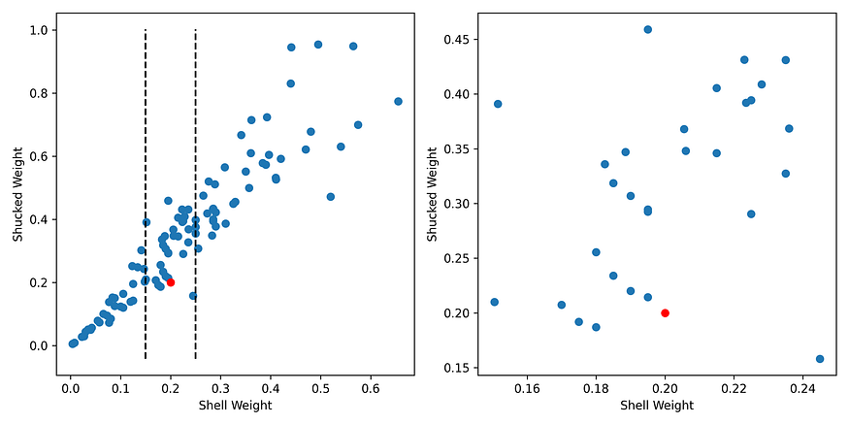
Figure 3: correlations within a small interval become meaningless
To avoid the correlation, we can determine the effect of shell weight within this interval. To do this, we create two samples from every instance in the interval. We call these sample pairs. As seen in Figure 4, we create them by replacing their shell weight value with the minimum and maximum shell weight values in the interval. All the other feature values remain the same.
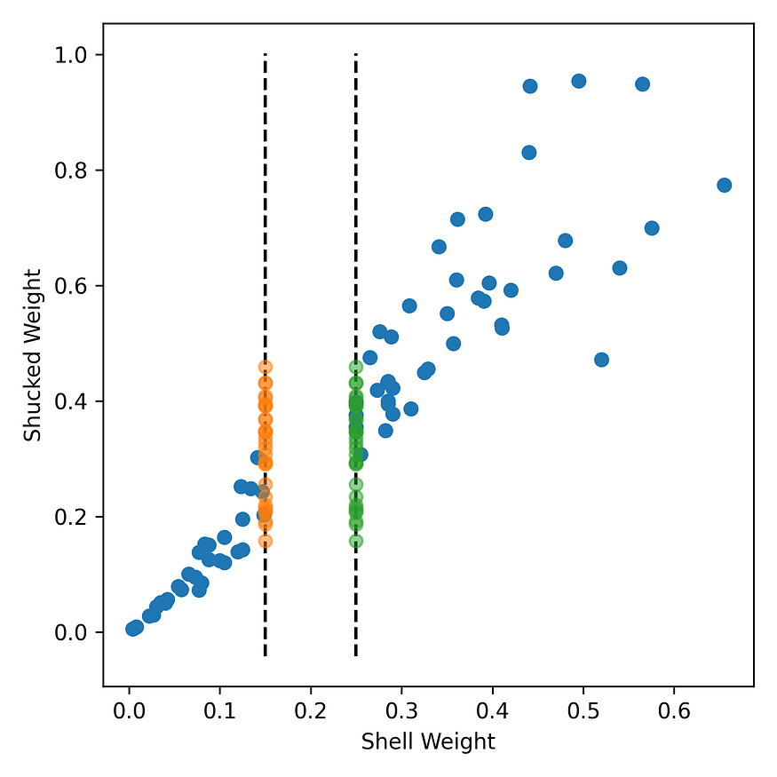
Figure 4: sample pairs created by replacing the shell weight values of instances in the interval. The orange instances use the minimum shell weight value of 1.5 and the green instances use the maximum value of 2.5.
The next step is to get the black-box model prediction for both samples in the sample pair. We then subtract the prediction for the min sample (orange) from the max sample (green). We do this for all sample pairs and calculate the average. This gives us an estimate of the effect on the prediction due to the change in the shell weight within this interval. Importantly, the correlation with shucked weight will not skew this estimate.
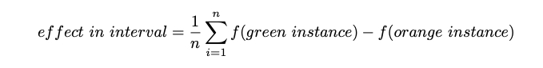
Okay, so this gives us the effect within a certain interval. To get the overall trend, we must do this for all consecutive intervals in the feature’s range and add the individual effects. Every time we move to a new interval we add the effect to the accumulated effect and plot a point. Doing this will give us the ALE for shell weight. We can now see where the name comes from. We are accumulating the feature effects within intervals (local).
Another way to look at ALEs, is they are similar to integration or at least a Riemann sum that approximates an integral. The local effects are the rate of change or derivative of the function. By accumulating the effects we are finding the black box model curve. The smaller our intervals the closer we are to the true curve. Unfortunately for ALEs, we cannot make the intervals infinitely small.
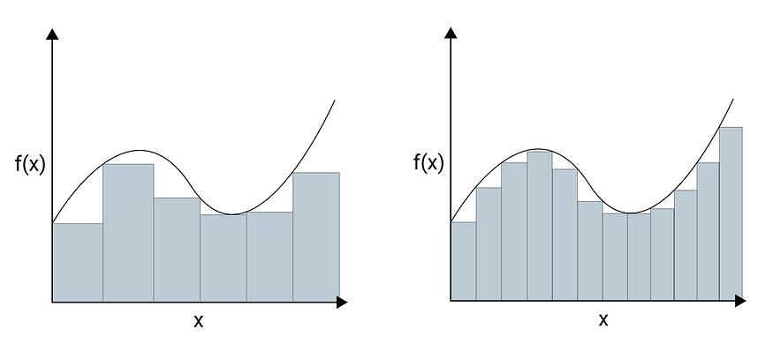

Formal algorithm
There is a mathematical formula for the ALE. I will save you from that this time. Still, it is worth defining the ALE algorithm more formally:
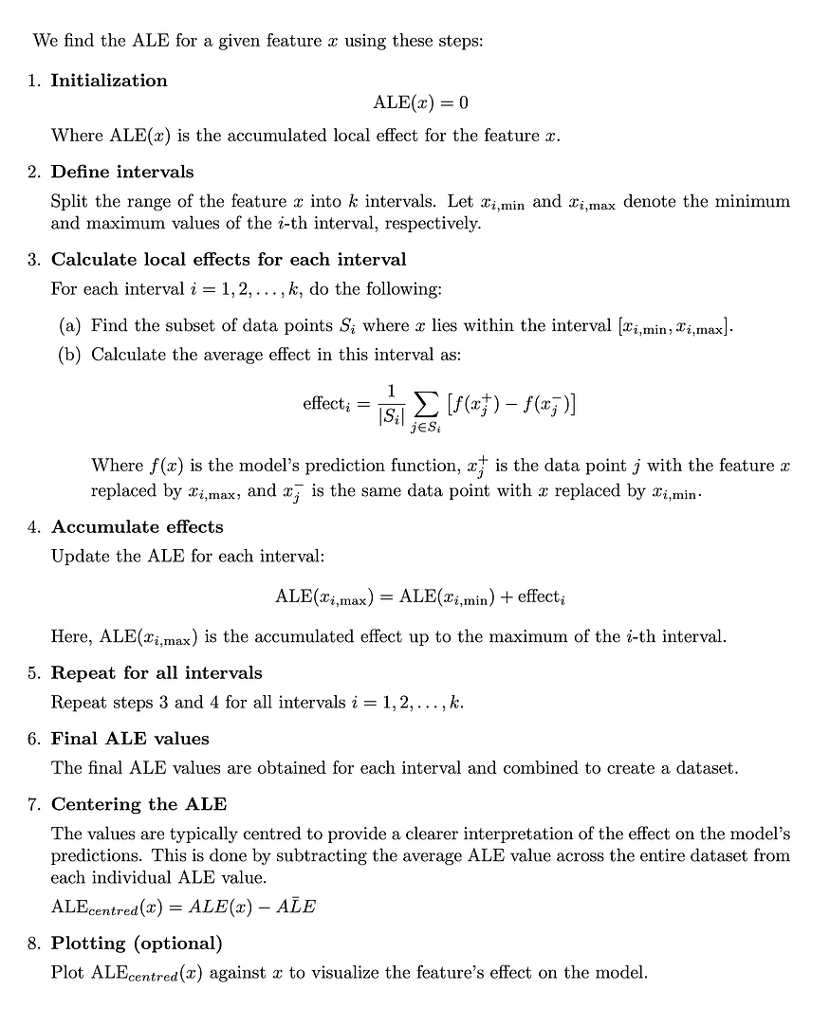
Different implementations may have slight variations on this algorithm. For example, the way we define the intervals in step 2. We will see that the implementation below will define them so that a minimum number of features will be included in each interval. It is also possible to define them using a constant width for each interval.

Applying ALEs with Alibi Explained
To apply ALEs, we will be using the alibi package. It provides a bunch of XAI methods. For now, we are interested in the ALE and plot_ale functions (lines 8–9). We will see how to apply this package and interpret its plots. We also explore how to combine multiple ALEs and change the interval length.
#imports
import pandas as pd
import numpy as np
import matplotlib.pyplot as plt
import seaborn as sns
from sklearn.ensemble import RandomForestRegressor
from alibi.explainers import ALE
from alibi.explainers import plot_ale

Dataset and model
We’ll be applying the method to the abalone dataset mentioned above. We load the dataset (lines 2–4) and select the target (line 6). We also do some feature engineering. First, we exclude diameter and whole weight from the feature list (line 7). This is because in Figure 1 we saw that they had a correlation of 1 with the other features. Finally, we create one-hot-encodings for the sex feature (lines 10–13). You can see a snapshot of the final feature set in Figure 5.
#import dataset
data = pd.read_csv("../../data/abalone.data",
names=["sex","length","diameter","height","whole weight",
"shucked weight","viscera weight","shell weight","rings"])
y = data["rings"]
X = data[["sex", "length", "height", "shucked weight", "viscera weight", "shell weight"]]
# Create dummy variables
X['sex.M'] = [1 if s == 'M' else 0 for s in X['sex']]
X['sex.F'] = [1 if s == 'F' else 0 for s in X['sex']]
X['sex.I'] = [1 if s == 'I' else 0 for s in X['sex']]
X = X.drop('sex', axis=1)
X.head()
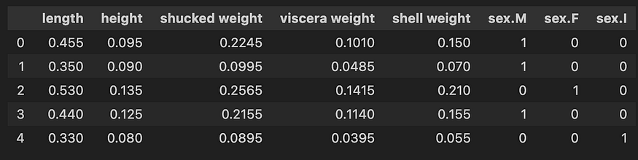
Figure 5: snapshot of abalone features
We use these features to train a model to predict the number of rings (lines 2–3). Notice that when training the model we convert the feature matrix to a numpy array. This is to avoid a warning message when creating ALEs.
# Train model
model = RandomForestRegressor()
model.fit(X.to_numpy(), y)

Plotting ALEs
To create ALE plots, we start by creating an ale object (line 2). To do this, we pass in our model’s prediction function (model.predict), feature names and target names. We then use this object to create explanations (exp) for our X feature matrix (line 3). The explain function requires that this matrix is a Numpy array.
# Get ALE explanation
ale = ALE(model.predict , feature_names=X.columns, target_names=['rings'])
exp = ale.explain(X.to_numpy())
To plot ALEs, we pass the explanations and features we want to display to the plot_ale. Using the array of positions [0,1,2] means we display the ALEs for the first 3 features. You can see these in Figure 6.
# Plot ALE explanation for first 3 features
plot_ale(exp, features=[0,1,2], fig_kw={'figwidth':15, 'figheight': 5})
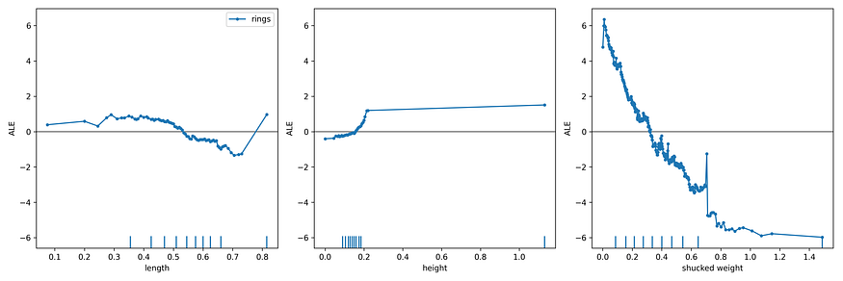
Figure 6: ALEs for length, height and shucked weight
Some conclusions we can make from Figure 6:
- The effect of length and height on the predicted number of rings is lower when compared to shucked weight.
- The downwards-sloping line for shucked weight indicates that the predicted number of rings tends to decrease as shucked weight increases.
We can also interpret individual points on a plot but first, we must understand how the plots have been centered. Let’s focus on the shucked weight relationship in Figure 7.
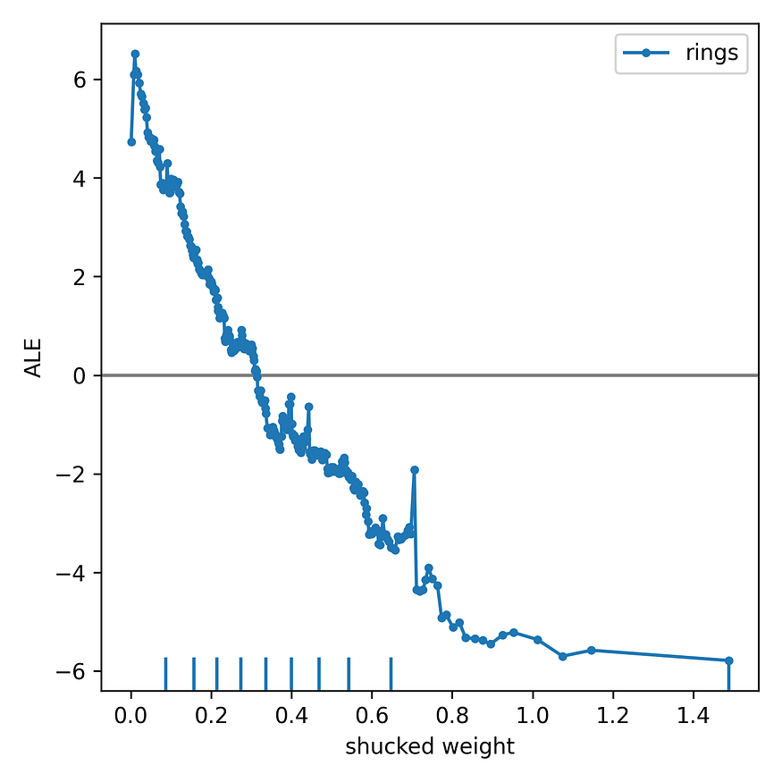
Figure 7: ALE for shucked weight
The ALE has been centred on 0. This is done by subtracting the average of the uncentered accumulated local effects from each uncentered accumulated local effect. This can be confusing at first. Finding the average of the ALE requires us to first sum the accumulated local effects at each point in the ALE. The result is that each point on an ALE will give the effect of the corresponding feature value when compared to the average effect of that feature. Or more simply, the effect when compared to the average prediction.
So, looking at the plot for shucked weight in Figure 7, we can make conclusions like:
- A shucked weight of 0 will increase the predicted number of rings by 6 compared to the average prediction.
- A shucked weight of 0 will increase the prediction by 12 compared to a shucked weight of 1.4.

Combining ALEs
Okay, let’s see what else we can do with the alibi package. If features have similar values, it may be useful to plot their ALEs on the same axis. Below, we do this for the 3 weight features. Looking at Figure 8, you can see how easy it is to compare the effects of these features.
# Plot ALE for weight features
fig, ax = plt.subplots(1, 1, figsize=(8, 4))
plot_ale(exp, features=[2], ax=ax, line_kw={'label': 'shucked weight'})
plot_ale(exp, features=[3], ax=ax, line_kw={'label': 'viscera weight'})
plot_ale(exp, features=[4], ax=ax, line_kw={'label': 'shell weight'})
ax.set_xlabel('weight')
Notice that shucked weight and shell weight have significant effects on the prediction. However, they are in the opposite direction. This is interesting! The features are highly correlated yet they have a different relationship with the predictions. This is due to an interaction between the two features — something we could explore using the H-stat (keep an eye out for a future article).
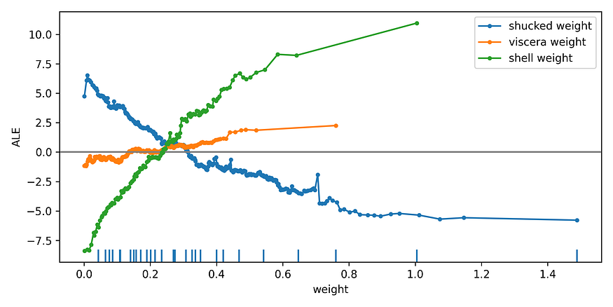
Figure 8: ALE for weight features
You may also notice that we have variable interval lengths. This has to do with the way the package selects intervals. By default, it will select intervals so that at least 4 instances are included. This is why you see a relatively large distance between the second last and last points in the ALEs. Our dataset becomes sparse for these weight values and we need a larger interval to capture at least 4 instances.

Increasing interval lengths
In the code below we create the same chart with one key difference. We have changed the minimum number of instances in an interval to 50 (line 3). This is done using the min_bin_points parameter. In Figure 9 you can see the result is a smoother ALE and larger intervals.
# Adjust intervals
ale = ALE(model.predict , feature_names=X.columns, target_names=['rings'])
exp = ale.explain(X.to_numpy(),min_bin_points=50)
fig, ax = plt.subplots(1, 1, figsize=(8, 4))
plot_ale(exp, features=[2], ax=ax, line_kw={'label': 'shucked weight'})
plot_ale(exp, features=[3], ax=ax, line_kw={'label': 'viscera weight'})
plot_ale(exp, features=[4], ax=ax, line_kw={'label': 'shell weight'})
ax.set_xlabel('weight')
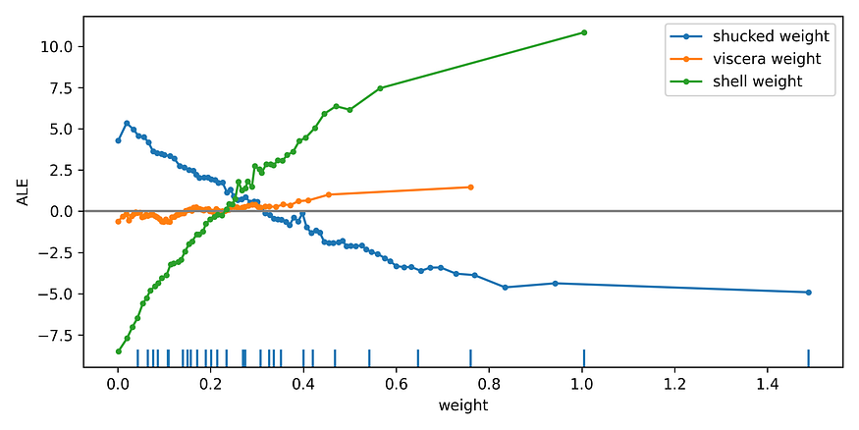
Figure 9: ALE for weight features with minimum interval size of 50
This min_bin_points introduces a trade-off when creating ALEs. As we decrease its values we decrease the size of the intervals. This will bring us closer to the true shape of the curve. However, we are faced with the issue of smaller sample sizes to estimate the effects within these intervals. In general, due to this uncertainty, we should focus on the overall trend instead of changes from interval to interval.
Another consideration is that, as we have seen, the interpretation of the ALE is clear but it is complicated to explain how we get to that interpretation. At least when compared to how PDPs are created. So, it is useful to use both methods. If their results agree, then you can always present the PDP. This can save you the headache of explaining what an average accumulated local effect is!

